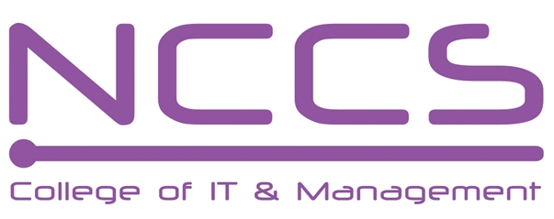
National College of Computer Studies
(NCCS-College of IT & Management)

Final Examination (2021)
BSc.CSIT/First Semester/ CSC – 110 : C Programming

Candidates are required to answer the questions in their own words as far as practicable.

Full Marks: 60
Pass Marks: 30
Time: 3 Hours
Set B

Attempt any Two Questions. [2×10=20]
- What is an array? Compare 1D array with 2D array. Write a program to add two matrices. [4+6]
- What is loop? Explain for loop with suitable example. Compare for loop with do while loop. Write a program to check whether a number is prime or not. [1+2+3+4]
- What do you mean by random access of file? Explain the different function used in random access of file in C. Write a program to display the content of file "csit.txt" in monitor in reverse order. [1+3+6]

Attempt any Eight Questions. [8×5=40]
- What is type conversion? Explain type casting with suitable example. [1+4=5]
- Define nested if else statement with suitable flowchart. Write a program to check whether a number is divisible by 7. [2+3=5]
- What is jumping statement? Differentiate break and continue statement with suitable example. [2+3=5]
- List the string functions in C.Write a program to check whether a word is palindrome or
not using. [1+4=5]
- What is DMA? Explain malloc() with suitable example. [1+4=5]
- Explain formatted I/O function in C with examples. [5]
- Explain user defined function with suitable example. [5]
- How a graphics driver can be initialized? Write a program to draw a two concentric circles at center of screen with radii 70 and 100. [1+4=5]
- Design a structure courses with member name, code and credit_hour. Write a main program to record of 10 courses using structure and display detail of those course whose credit_hour is less than 5. [5]

********
Note: Please send your answer sheet to the following e-mail address.
To: csit10batch@nccs.edu.np
CC: dinesh.khadka@gmail.com

